healthcare_ehr | SBP
V1.0

Revision History
Version | Date | Description | Author
1.0 | 18/02/2026 | Initial Version | Mohammed Megahed

Reviewers
# | Name | Position | Date and Signature
1
2

Acceptance and Signoff
# | Name | Position | Date and Signature
1
2

Contents
1. Introduction 4
1.1. Project Summary 4
1.2. In-Scope 4
1.3. Out-Scope 4
1.4. Target Audience 4
1.5. Abbreviations 4
1.6. Assumptions, Dependencies and Risks 4
2. Requirements Compliancy Matrix 5
3. Solution Architecture 6
3.1. Solution Description 6
3.2. Security Considerations 6
4. Patient Clinical Encounter 7
4.1. Sequence Diagram 7
4.2. Flow Description 7
4.3. APIs Contract Agreement 10
4.4. Error Handling 11
5. Electronic Prescription (e-Prescribing) 17
5.1. Sequence Diagram 17
5.2. Flow Description 18
5.3. APIs Contract Agreement 19
6. Appendix 21
6.1. Solution Architecture Reference Documents 21

1. Introduction

1.1. Project Summary
This project builds a comprehensive Electronic Health Records (EHR) system for hospitals, securely storing patient data, clinical notes, and lab results. Key capabilities include clinical documentation, order management, e-prescribing, and integration with lab and radiology systems. The primary business benefit is improved patient care and operational efficiency.

1.2. In-Scope
# | Item
1. | Patient registration and demographics
2. | Clinical documentation (notes, assessments)
3. | Problem list and allergy management
4. | Laboratory order placement and results
5. | Electronic prescribing with drug interaction checking
6. | Appointment scheduling
7. | Clinical decision support alerts

1.3. Out-Scope
# | Item
1. | Hospital billing and revenue cycle
2. | Inventory and supply chain management
3. | Human resources management
4. | Telemedicine video consultations

1.4. Target Audience
# | Stakeholders
1. | Enterprise Architects
2. | Partners and Vendors Technical Leaders
3. | Infrastructure Architects & Engineers
4. | InfoSec Architects & Engineers
5. | Technical Managers
6. | Delivery Leads and Project Managers
7. | Developers

1.5. Abbreviations
# | Abbreviations | Full form
1

1.6. Assumptions, Dependencies and Risks
# | Item | Type | Owner | Comment
1.
2.

2. Requirements Compliancy Matrix
ID. | Title | Description | Compliancy | Comments
FR-1 | MediCare is a comprehensive Electronic Health Records system for hospitals and c | This requirement enables medicare is a comprehensive electronic health records system for hospitals and c functionality for users. | Compliant
FR-2 | The platform supports clinical documentation, order management, and e-prescribin | This requirement enables the platform supports clinical documentation, order management, and e-prescribin functionality for users. | Compliant
FR-3 | Integration with laboratory and radiology systems provides complete diagnostic w | This requirement enables integration with laboratory and radiology systems provides complete diagnostic w functionality for users. | Compliant
FR-BR-001 | Patient Registration | This requirement enables patient registration functionality for users. | Compliant
FR-BR-002 | Medical History | This requirement enables medical history functionality for users. | Compliant
FR-BR-003 | Clinical Notes | This requirement enables clinical notes functionality for users. | Compliant
FR-BR-004 | Diagnosis Coding | This requirement enables diagnosis coding functionality for users. | Compliant
FR-BR-005 | Lab Orders | This requirement enables lab orders functionality for users. | Compliant
FR-BR-006 | e-Prescribing | This requirement enables e-prescribing functionality for users. | Compliant
FR-BR-007 | Drug Interactions | This requirement enables drug interactions functionality for users. | Compliant
FR-BR-008 | Scheduling | This requirement enables scheduling functionality for users. | Compliant
FR-BR-009 | lerts | This requirement enables lerts functionality for users. | Compliant
FR-BR-010 | Audit Trail | This requirement enables audit trail functionality for users. | Compliant

3. Solution Architecture

3.1. Solution Description
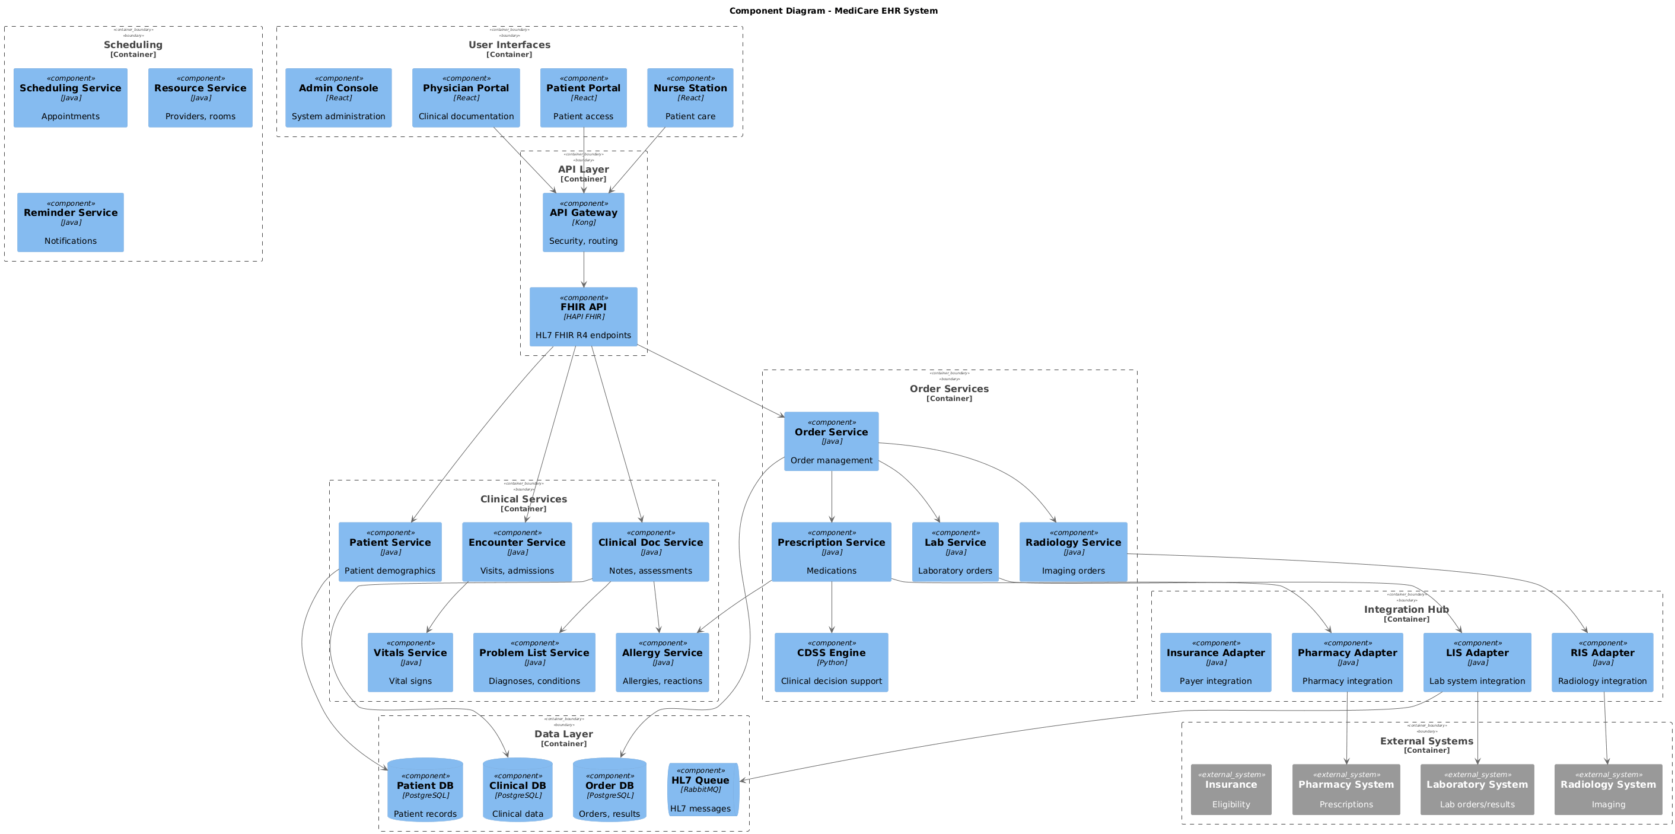

3.2. Security Considerations
# | Security Domain | Requirement | Implementation
1 | Authentication | User Authentication | OAuth 2.0 / JWT tokens with secure token storage
2 | Authentication | Service-to-Service Auth | Mutual TLS (mTLS) for internal service communication
3 | Authentication | Multi-Factor Authentication | MFA required for sensitive operations
4 | Authorization | Role-Based Access Control | RBAC implemented with principle of least privilege
5 | Authorization | API Authorization | Scope-based access control for API endpoints
6 | Data Protection | Data in Transit | TLS 1.2+ encryption for all network communication
7 | Data Protection | Data at Rest | AES-256 encryption for sensitive data storage
8 | Data Protection | PII/Sensitive Data | Data masking and tokenization for sensitive fields
9 | API Security | Input Validation | Server-side validation of all input parameters
10 | API Security | Rate Limiting | Rate limiting to prevent abuse and DDoS attacks
11 | API Security | CORS Policy | Strict CORS policy for web API endpoints
12 | Audit & Logging | Audit Trail | Log all security-relevant events with timestamps
13 | Audit & Logging | Log Protection | Immutable logs with tamper detection
14 | Vulnerability Management | Security Scanning | Regular SAST/DAST scanning in CI/CD pipeline
15 | Vulnerability Management | Dependency Scanning | Automated scanning for vulnerable dependencies

4. Patient Clinical Encounter

4.1. Sequence Diagram
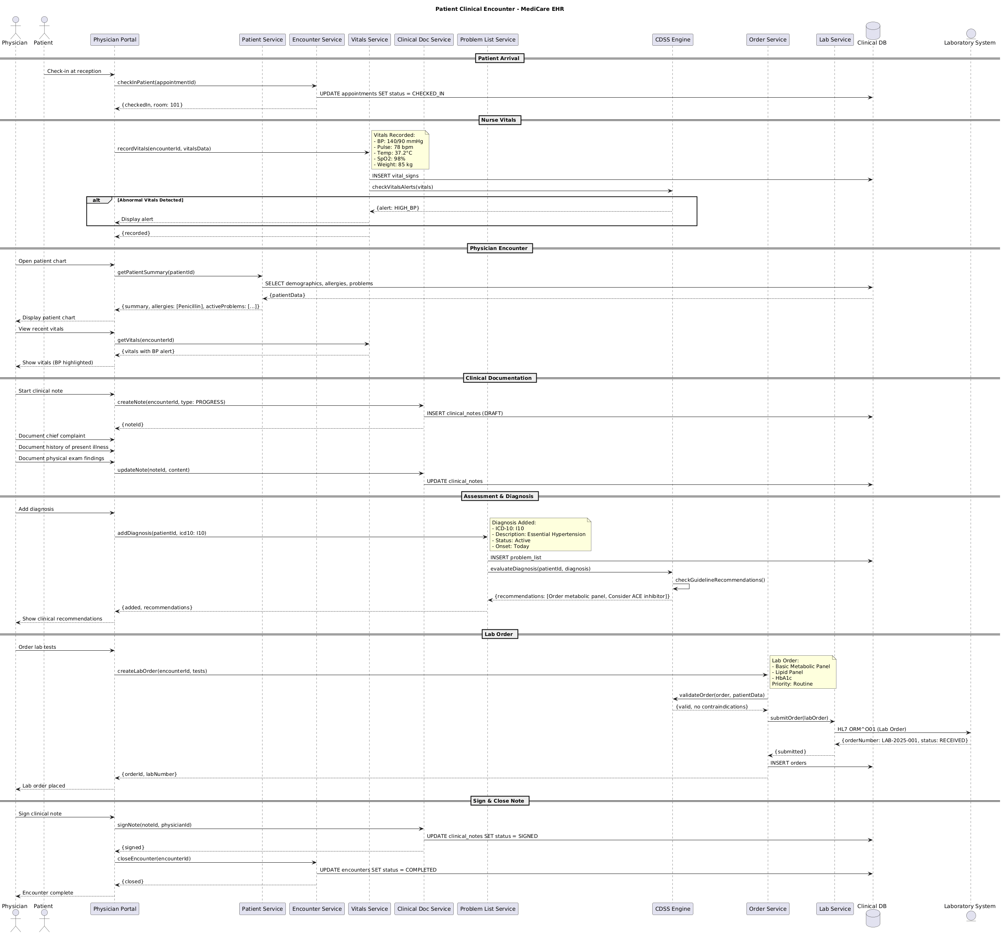

4.2. Flow Description
Patient Arrival
• Physician -> Physician Portal: Check-in at reception
• Physician Portal -> Encounter Service: checkInPatient
• Encounter Service -> Clinical DB: UPDATE appointments SET status = CHECKED_IN
• Physician Portal <-- Encounter Service: {checkedIn, room: 101}
Nurse Vitals
• Physician Portal -> Vitals Service: recordVitals(encounterId, vitalsData)
• Vitals Service -> Clinical DB: INSERT vital_signs
• Vitals Service -> CDSS Engine: checkVitalsAlerts
Alt: IF [Abnormal Vitals Detected] THEN
• Vitals Service <-- CDSS Engine: {alert: HIGH_BP}
• Physician Portal <-- Vitals Service: Display alert
• Physician Portal <-- Vitals Service: {recorded}
Physician Encounter
• Physician -> Physician Portal: Open patient chart
• Physician Portal -> Patient Service: getPatientSummary
• Patient Service -> Clinical DB: SELECT demographics, allergies, problems
• Patient Service <-- Clinical DB: {patientData}
• Physician Portal <-- Patient Service: {summary, allergies: [Penicillin], activeProblems: [...]}
• Physician <-- Physician Portal: Display patient chart
• Physician -> Physician Portal: View recent vitals
• Physician Portal -> Vitals Service: getVitals
• Physician Portal <-- Vitals Service: {vitals with BP alert}
• Physician <-- Physician Portal: Show vitals (BP highlighted)
Clinical Documentation
• Physician -> Physician Portal: Start clinical note
• Physician Portal -> Clinical Doc Service: createNote(encounterId, type: PROGRESS)
• Clinical Doc Service -> Clinical DB: INSERT clinical_notes
• Physician Portal <-- Clinical Doc Service: {noteId}
• Physician -> Physician Portal: Document chief complaint
• Physician -> Physician Portal: Document history of present illness
• Physician -> Physician Portal: Document physical exam findings
• Clinical Doc Service -> Clinical DB: UPDATE clinical_notes
Assessment & Diagnosis
• Physician -> Physician Portal: Add diagnosis
• Physician Portal -> Problem List Service: addDiagnosis(patientId, icd10: I10)
• Problem List Service -> Clinical DB: INSERT problem_list
• Problem List Service -> CDSS Engine: evaluateDiagnosis(patientId, diagnosis)
• CDSS Engine internally performs: checkGuidelineRecommendations()
• Problem List Service <-- CDSS Engine: {recommendations: [Order metabolic panel, Consider ACE inhibitor]}
• Physician Portal <-- Problem List Service: {added, recommendations}
• Physician <-- Physician Portal: Show clinical recommendations
Lab Order
• Physician -> Physician Portal: Order lab tests
• Physician Portal -> Order Service: createLabOrder(encounterId, tests)
• Order Service -> CDSS Engine: validateOrder(order, patientData)
• Order Service <-- CDSS Engine: {valid, no contraindications}
• Order Service -> Lab Service: submitOrder
• Lab Service -> Laboratory System: HL7 ORM^O01 (Lab Order)
• Lab Service <-- Laboratory System: {orderNumber: LAB-2025-001, status: RECEIVED}
• Order Service <-- Lab Service: {submitted}
• Order Service -> Clinical DB: INSERT orders
• Physician Portal <-- Order Service: {orderId, labNumber}
• Physician <-- Physician Portal: Lab order placed
Sign & Close Note
• Physician -> Physician Portal: Sign clinical note
• Physician Portal -> Clinical Doc Service: signNote(noteId, physicianId)
• Clinical Doc Service -> Clinical DB: UPDATE clinical_notes SET status = SIGNED
• Physician Portal <-- Clinical Doc Service: {signed}
• Physician Portal -> Encounter Service: closeEncounter
• Encounter Service -> Clinical DB: UPDATE encounters SET status = COMPLETED
• Physician Portal <-- Encounter Service: {closed}
• Physician <-- Physician Portal: Encounter complete
  - Authentication & Validation
The flow includes internal processing for vitals alerts, clinical documentation, diagnosis assessment, lab orders, and sign-off of the clinical note. Each self-interaction is described as a separate sentence, representing important internal processing such as UI updates, caching, validation, flag-setting, computation, and decision logic. These internal interactions are critical to the flow's functionality and must be accurately described.

4.3. APIs Contract Agreement
# | Source | Destination | API | Protocol | Request Parameters | Response Parameters
1 | Physician Portal | Encounter Service | checkInPatient | REST | appointmentId | {checkedIn, room: 101}
2 | Encounter Service | Clinical DB | UPDATE appointments SET status = CHECKED_IN | JDBC
3 | Physician Portal | Vitals Service | recordVitals | REST | encounterId, vitalsData | Display alert
4 | Vitals Service | Clinical DB | INSERT vital_signs | JDBC
5 | Vitals Service | CDSS Engine | checkVitalsAlerts | REST | vitals | {alert: HIGH_BP}
6 | Physician Portal | Patient Service | getPatientSummary | REST | patientId | {summary, allergies: [Penicillin], activeProblems: [...]}
7 | Patient Service | Clinical DB | SELECT demographics, allergies, problems | JDBC |  | {patientData}
8 | Physician Portal | Vitals Service | getVitals | REST | encounterId | {vitals with BP alert}
9 | Physician Portal | Clinical Doc Service | createNote | REST | encounterId, type: PROGRESS | {noteId}
10 | Clinical Doc Service | Clinical DB | INSERT clinical_notes | JDBC | DRAFT
11 | Physician Portal | Clinical Doc Service | updateNote | REST | noteId, content | {signed}
12 | Clinical Doc Service | Clinical DB | UPDATE clinical_notes | JDBC
13 | Physician Portal | Problem List Service | addDiagnosis | REST | patientId, icd10: I10 | {added, recommendations}
14 | Problem List Service | Clinical DB | INSERT problem_list | JDBC
15 | Problem List Service | CDSS Engine | evaluateDiagnosis | REST | patientId, diagnosis | {recommendations: [Order metabolic panel, Consider ACE inhibitor]}
16 | Physician Portal | Order Service | createLabOrder | REST | encounterId, tests | {orderId, labNumber}
17 | Order Service | CDSS Engine | validateOrder | REST | order, patientData | {valid, no contraindications}
18 | Order Service | Lab Service | submitOrder | REST | labOrder | {submitted}
19 | Lab Service | Laboratory System | HL7 ORM^O01 | REST | Lab Order | {orderNumber: LAB-2025-001, status: RECEIVED}
20 | Order Service | Clinical DB | INSERT orders | JDBC
21 | Physician Portal | Clinical Doc Service | signNote | REST | noteId, physicianId
22 | Clinical Doc Service | Clinical DB | UPDATE clinical_notes SET status = SIGNED | JDBC
23 | Physician Portal | Encounter Service | closeEncounter | REST | encounterId | {closed}
24 | Encounter Service | Clinical DB | UPDATE encounters SET status = COMPLETED | JDBC
[*] Indicates that the data element is optional

4.4. Error Handling
# | Source | Destination | Scenario | Handling
1 | External APIC | ACE-Integration | getInternationalBeneficiarySupportedCountries  Service Unavailability | Ensure idempotency to avoid duplicates on retry; Log error with correlation ID; Retry up to 3 times with exponential backoff; Notify user of failure
2 | External APIC | ACE-Integration | createInternationalBeneficiaryRequest  Duplicate Request | Ensure idempotency to avoid duplicates on retry; Log error with correlation ID; Retry up to 3 times with exponential backoff; Notify user of failure
3 | External APIC | ACE-Integration | createInternationalBeneficiaryRequest  Validation Failure | Ensure idempotency to avoid duplicates on retry; Log error with correlation ID; Retry up to 3 times with exponential backoff; Notify user of failure
4 | External APIC | ACE-Integration | createInternationalBeneficiaryRequest  Partial Completion | Ensure idempotency to avoid duplicates on retry; Log error with correlation ID; Retry up to 3 times with exponential backoff; Notify user of failure
5 | External APIC | ACE-Integration | createInternationalBeneficiaryRequest  Timeout | Ensure idempotency to avoid duplicates on retry; Log error with correlation ID; Retry up to 3 times with exponential backoff; Notify user of failure
6 | External APIC | ACE-Integration | createInternationalBeneficiaryRequest  Service Unavailability | Ensure idempotency to avoid duplicates on retry; Log error with correlation ID; Retry up to 3 times with exponential backoff; Notify user of failure
7 | External APIC | ACE-Integration | createInternationalBeneficiaryRequest  Data Not Found | Ensure idempotency to avoid duplicates on retry; Log error with correlation ID; Retry up to 3 times with exponential backoff; Notify user of failure
8 | External APIC | ACE-Integration | createInternationalBeneficiaryRequest  Validation Failure | Ensure idempotency to avoid duplicates on retry; Log error with correlation ID; Retry up to 3 times with exponential backoff; Notify user of failure
9 | External APIC | ACE-Integration | createInternationalBeneficiaryRequest  Timeout | Ensure idempotency to avoid duplicates on retry; Log error with correlation ID; Retry up to 3 times with exponential backoff; Notify user of failure
10 | External APIC | ACE-Integration | createInternationalBeneficiaryRequest  Service Unavailability | Ensure idempotency to avoid duplicates on retry; Log error with correlation ID; Retry up to 3 times with exponential backoff; Notify user of failure
11 | External APIC | ACE-Integration | createInternationalBeneficiaryRequest  Data Not Found | Ensure idempotency to avoid duplicates on retry; Log error with correlation ID; Retry up to 3 times with exponential backoff; Notify user of failure
12 | External APIC | ACE-Integration | createInternationalBeneficiaryRequest  Validation Failure | Ensure idempotency to avoid duplicates on retry; Log error with correlation ID; Retry up to 3 times with exponential backoff; Notify user of failure
13 | External APIC | ACE-Integration | createInternationalBeneficiaryRequest  Timeout | Ensure idempotency to avoid duplicates on retry; Log error with correlation ID; Retry up to 3 times with exponential backoff; Notify user of failure
14 | External APIC | ACE-Integration | createInternationalBeneficiaryRequest  Service Unavailability | Ensure idempotency to avoid duplicates on retry; Log error with correlation ID; Retry up to 3 times with exponential backoff; Notify user of failure
15 | External APIC | ACE-Integration | createInternationalBeneficiaryRequest  Data Not Found | Ensure idempotency to avoid duplicates on retry; Log error with correlation ID; Retry up to 3 times with exponential backoff; Notify user of failure
16 | External APIC | ACE-Integration | createInternationalBeneficiaryRequest  Validation Failure | Ensure idempotency to avoid duplicates on retry; Log error with correlation ID; Retry up to 3 times with exponential backoff; Notify user of failure
17 | External APIC | ACE-Integration | createInternationalBeneficiaryRequest  Timeout | Ensure idempotency to avoid duplicates on retry; Log error with correlation ID; Retry up to 3 times with exponential backoff; Notify user of failure
18 | External APIC | ACE-Integration | createInternationalBeneficiaryRequest  Service Unavailability | Ensure idempotency to avoid duplicates on retry; Log error with correlation ID; Retry up to 3 times with exponential backoff; Notify user of failure
19 | External APIC | ACE-Integration | createInternationalBeneficiaryRequest  Data Not Found | Ensure idempotency to avoid duplicates on retry; Log error with correlation ID; Retry up to 3 times with exponential backoff; Notify user of failure
20 | External APIC | ACE-Integration | createInternationalBeneficiaryRequest  Validation Failure | Ensure idempotency to avoid duplicates on retry; Log error with correlation ID; Retry up to 3 times with exponential backoff; Notify user of failure
21 | External APIC | ACE-Integration | createInternationalBeneficiaryRequest  Timeout | Ensure idempotency to avoid duplicates on retry; Log error with correlation ID; Retry up to 3 times with exponential backoff; Notify user of failure
22 | External APIC | ACE-Integration | createInternationalBeneficiaryRequest  Service Unavailability | Ensure idempotency to avoid duplicates on retry; Log error with correlation ID; Retry up to 3 times with exponential backoff; Notify user of failure
23 | External APIC | ACE-Integration | createInternationalBeneficiaryRequest  Data Not Found | Ensure idempotency to avoid duplicates on retry; Log error with correlation ID; Retry up to 3 times with exponential backoff; Notify user of failure
24 | External APIC | ACE-Integration | createInternationalBeneficiaryRequest  Validation Failure | Ensure idempotency to avoid duplicates on retry; Log error with correlation ID; Retry up to 3 times with exponential backoff; Notify user of failure
25 | External APIC | ACE-Integration | createInternationalBeneficiaryRequest  Timeout | Ensure idempotency to avoid duplicates on retry; Log error with correlation ID; Retry up to 3 times with exponential backoff; Notify user of failure
26 | External APIC | ACE-Integration | createInternationalBeneficiaryRequest  Service Unavailability | Ensure idempotency to avoid duplicates on retry; Log error with correlation ID; Retry up to 3 times with exponential backoff; Notify user of failure
27 | External APIC | ACE-Integration | createInternationalBeneficiaryRequest  Data Not Found | Ensure idempotency to avoid duplicates on retry; Log error with correlation ID; Retry up to 3 times with exponential backoff; Notify user of failure
28 | External APIC | ACE-Integration | createInternationalBeneficiaryRequest  Validation Failure | Ensure idempotency to avoid duplicates on retry; Log error with correlation ID; Retry up to 3 times with exponential backoff; Notify user of failure
29 | External APIC | ACE-Integration | createInternationalBeneficiaryRequest  Timeout | Ensure idempotency to avoid duplicates on retry; Log error with correlation ID; Retry up to 3 times with exponential backoff; Notify user of failure
30 | External APIC | ACE-Integration | createInternationalBeneficiaryRequest  Service Unavailability | Ensure idempotency to avoid duplicates on retry; Log error with correlation ID; Retry up to 3 times with exponential backoff; Notify user of failure
31 | External APIC | ACE-Integration | createInternationalBeneficiaryRequest  Data Not Found | Ensure idempotency to avoid duplicates on retry; Log error with correlation ID; Retry up to 3 times with exponential backoff; Notify user of failure
32 | External APIC | ACE-Integration | createInternationalBeneficiaryRequest  Validation Failure | Ensure idempotency to avoid duplicates on retry; Log error with correlation ID; Retry up to 3 times with exponential backoff; Notify user of failure
33 | External APIC | ACE-Integration | createInternationalBeneficiaryRequest  Timeout | Ensure idempotency to avoid duplicates on retry; Log error with correlation ID; Retry up to 3 times with exponential backoff; Notify user of failure
34 | External APIC | ACE-Integration | createInternationalBeneficiaryRequest  Service Unavailability | Ensure idempotency to avoid duplicates on retry; Log error with correlation ID; Retry up to 3 times with exponential backoff; Notify user of failure
35 | External APIC | ACE-Integration | createInternationalBeneficiaryRequest  Data Not Found | Ensure idempotency to avoid duplicates on retry; Log error with correlation ID; Retry up to 3 times with exponential backoff; Notify user of failure
36 | External APIC | ACE-Integration | createInternationalBeneficiaryRequest  Validation Failure | Ensure idempotency to avoid duplicates on retry; Log error with correlation ID; Retry up to 3 times with exponential backoff; Notify user of failure
37 | External APIC | ACE-Integration | createInternationalBeneficiaryRequest  Timeout | Ensure idempotency to avoid duplicates on retry; Log error with correlation ID; Retry up to 3 times with exponential backoff; Notify user of failure
38 | External APIC | ACE-Integration | createInternationalBeneficiaryRequest  Service Unavailability | Ensure idempotency to avoid duplicates on retry; Log error with correlation ID; Retry up to 3 times with exponential backoff; Notify user of failure
39 | External APIC | ACE-Integration | createInternationalBeneficiaryRequest  Data Not Found | Ensure idempotency to avoid duplicates on retry; Log error with correlation ID; Retry up to 3 times with exponential backoff; Notify user of failure
40 | External APIC | ACE-Integration | createInternationalBeneficiaryRequest  Validation Failure | Ensure idempotency to avoid duplicates on retry; Log error with correlation ID; Retry up to 3 times with exponential backoff; Notify user of failure
41 | External APIC | ACE-Integration | createInternationalBeneficiaryRequest  Timeout | Ensure idempotency to avoid duplicates on retry; Log error with correlation ID; Retry up to 3 times with exponential backoff; Notify user of failure
42 | External APIC | ACE-Integration | createInternationalBeneficiaryRequest  Service Unavailability | Ensure idempotency to avoid duplicates on retry; Log error with correlation ID; Retry up to 3 times with exponential backoff; Notify user of failure
43 | External APIC | ACE-Integration | createInternationalBeneficiaryRequest  Data Not Found | Ensure idempotency to avoid duplicates on retry; Log error with correlation ID; Retry up to 3 times with exponential backoff; Notify user of failure
44 | External APIC | ACE-Integration | createInternationalBeneficiaryRequest  Validation Failure | Ensure idempotency to avoid duplicates on retry; Log error with correlation ID; Retry up to 3 times with exponential backoff; Notify user of failure
45 | External APIC | ACE-Integration | createInternationalBeneficiaryRequest  Timeout | Ensure idempotency to avoid duplicates on retry; Log error with correlation ID; Retry up to 3 times with exponential backoff; Notify user of failure
46 | External APIC | ACE-Integration | createInternationalBeneficiaryRequest  Service Unavailability | Ensure idempotency to avoid duplicates on retry; Log error with correlation ID; Retry up to 3 times with exponential backoff; Notify user of failure
47 | External APIC | ACE-Integration | createInternationalBeneficiaryRequest  Data Not Found | Ensure idempotency to avoid duplicates on retry; Log error with correlation ID; Retry up to 3 times with exponential backoff; Notify user of failure
48 | External APIC | ACE-Integration | createInternationalBeneficiaryRequest  Validation Failure | Ensure idempotency to avoid duplicates on retry; Log error with correlation ID; Retry up to 3 times with exponential backoff; Notify user of failure
49 | External APIC | ACE-Integration | createInternationalBeneficiaryRequest  Timeout | Ensure idempotency to avoid duplicates on retry; Log error with correlation ID; Retry up to 3 times with exponential backoff; Notify user of failure
50 | External APIC | ACE-Integration | createInternationalBeneficiaryRequest  Service Unavailability | Ensure idempotency to avoid duplicates on retry; Log error with correlation ID; Retry up to 3 times with exponential backoff; Notify user of failure
51 | External APIC | ACE-Integration | createInternationalBeneficiaryRequest  Data Not Found | Ensure idempotency to avoid duplicates on retry; Log error with correlation ID; Retry up to 3 times with exponential backoff; Notify user of failure
52 | External APIC | ACE-Integration | createInternationalBeneficiaryRequest  Validation Failure | Ensure idempotency to avoid duplicates on retry; Log error with correlation ID; Retry up to 3 times with exponential backoff; Notify user of failure
53 | External APIC | ACE-Integration | createInternationalBeneficiaryRequest  Timeout | Ensure idempotency to avoid duplicates on retry; Log error with correlation ID; Retry up to 3 times with exponential backoff; Notify user of failure
54 | External APIC | ACE-Integration | createInternationalBeneficiaryRequest  Service Unavailability | Ensure idempotency to avoid duplicates on retry; Log error with correlation ID; Retry up to 3 times with exponential backoff; Notify user of failure
55 | External APIC | ACE-Integration | createInternationalBeneficiaryRequest  Data Not Found | Ensure idempotency to avoid duplicates on retry; Log error with correlation ID; Retry up to 3 times with exponential backoff; Notify user of failure
56 | External APIC | ACE-Integration | createInternationalBeneficiaryRequest  Validation Failure | Ensure idempotency to avoid duplicates on retry; Log error with correlation ID; Retry up to 3 times with exponential backoff; Notify user of failure
57 | External APIC | ACE-Integration | createInternationalBeneficiaryRequest  Timeout | Ensure idempotency to avoid duplicates on retry; Log error with correlation ID; Retry up to 3 times with exponential backoff; Notify user of failure
58 | External APIC | ACE-Integration | createInternationalBeneficiaryRequest  Service Unavailability | Ensure idempotency to avoid duplicates on retry; Log error with correlation ID; Retry up to 3 times with exponential backoff; Notify user of failure
59 | External APIC | ACE-Integration | createInternationalBeneficiaryRequest  Data Not Found | Ensure idempotency to avoid duplicates on retry; Log error with correlation ID; Retry up to 3 times with exponential backoff; Notify user of failure
60 | External APIC | ACE-Integration | createInternationalBeneficiaryRequest  Validation Failure | Ensure idemp

5. Electronic Prescription (e-Prescribing)

5.1. Sequence Diagram
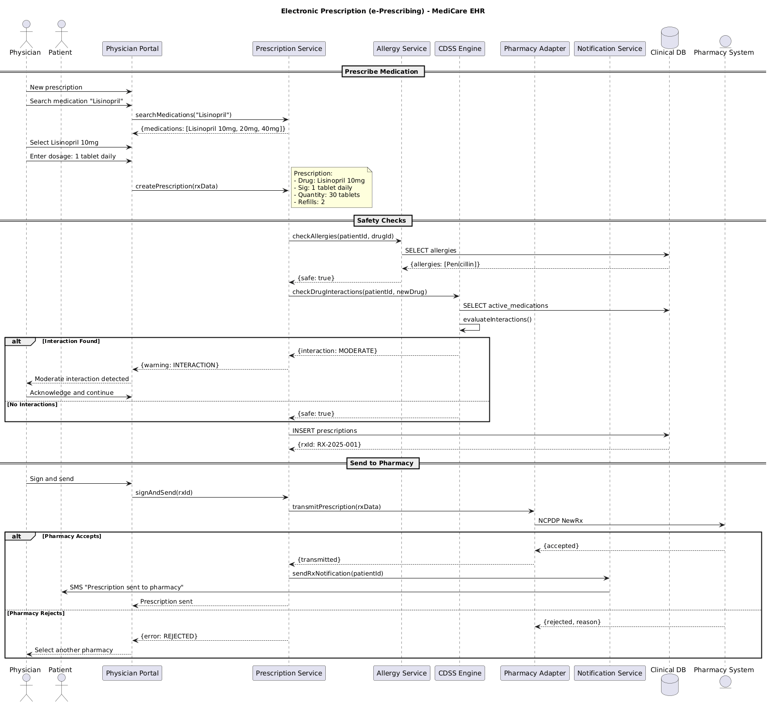

5.2. Flow Description
Prescription
• Drug: Lisinopril 10mg
• Sig: 1 tablet daily
• Quantity: 30 tablets
• Refills: 2
ALTERNATIVE & CONDITIONAL FLOWS:
ALT: Interaction Found
BRANCH [Interaction Found]:
Prescription Service <- CDSS Engine: {interaction: MODERATE}
Physician Portal <- Prescription Service: {warning: INTERACTION}
Physician <- Physician Portal: Moderate interaction detected
Physician -> Physician Portal: Acknowledge and continue
BRANCH [No Interactions]:
Prescription Service <- CDSS Engine: {safe: true}
ALT: Pharmacy Accepts
BRANCH [Pharmacy Accepts]:
Pharmacy Adapter <- Pharmacy System: {accepted}
Prescription Service <- Pharmacy Adapter: {transmitted}
Prescription Service -> Notification Service: sendRxNotification
Notification Service -> Patient: SMS "Prescription sent to pharmacy"
Physician Portal <- Prescription Service: Prescription sent
BRANCH [Pharmacy Rejects]:
Pharmacy Adapter <- Pharmacy System: {rejected, reason}
Physician Portal <- Prescription Service: {error: REJECTED}
Physician <- Physician Portal: Select another pharmacy
FLOW PHASES/SECTIONS:
• Prescribe Medication
• Safety Checks
• Send to Pharmacy

5.3. APIs Contract Agreement
# | Source | Destination | API | Protocol | Request Parameters | Response Parameters
1 | Physician Portal | Prescription Service | searchMedications | REST | "Lisinopril" | {medications: [Lisinopril 10mg, 20mg, 40mg]}
2 | Physician Portal | Prescription Service | createPrescription | REST | rxData | {warning: INTERACTION}
3 | Prescription Service | Allergy Service | checkAllergies | REST | patientId, drugId | {safe: true}
4 | Allergy Service | Clinical DB | SELECT allergies | JDBC |  | {allergies: [Penicillin]}
5 | Prescription Service | CDSS Engine | checkDrugInteractions | REST | patientId, newDrug | {interaction: MODERATE}
6 | CDSS Engine | Clinical DB | SELECT active_medications | JDBC
7 | Prescription Service | Clinical DB | INSERT prescriptions | JDBC |  | {rxId: RX-2025-001}
8 | Physician Portal | Prescription Service | signAndSend | REST | rxId | Prescription sent
9 | Prescription Service | Pharmacy Adapter | transmitPrescription | REST | rxData | {transmitted}
10 | Pharmacy Adapter | Pharmacy System | NCPDP NewRx | REST |  | {accepted}
11 | Prescription Service | Notification Service | sendRxNotification | REST | patientId
12 | Notification Service | Patient | SMS "Prescription sent to pharmacy" | REST
[*] Indicates that the data element is optional

6. Appendix

6.1. Solution Architecture Reference Documents
# | Name | File
1 | BRD | Refer to Latest BRD Attached to JIRA Ticket

